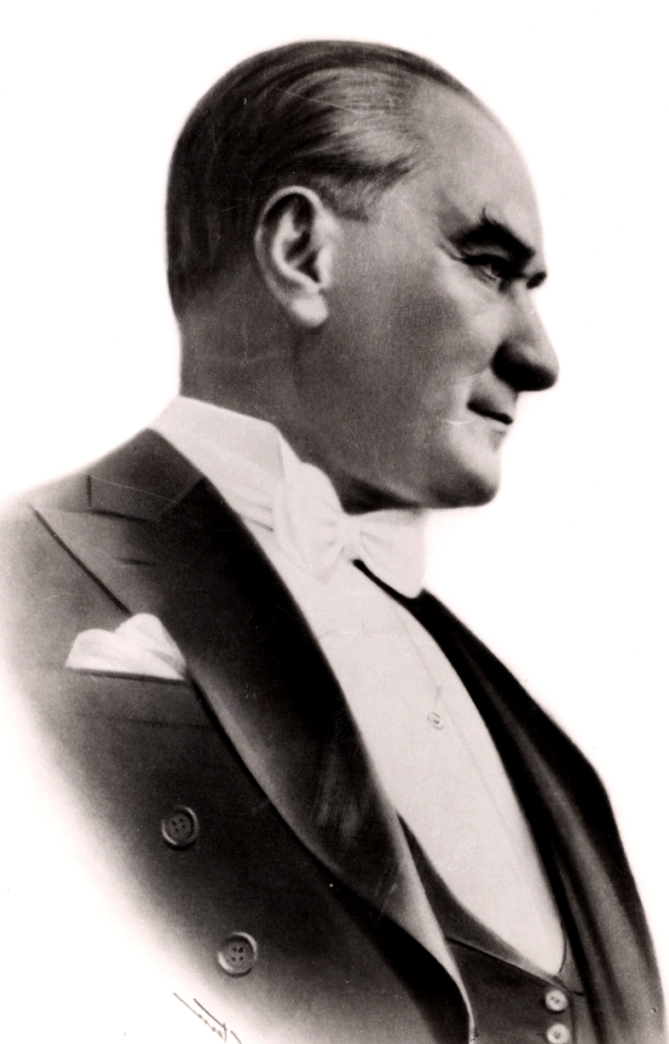

Mustafa Kemal ATATÜRK 1881-1938

